Marathwada Shikshan Prasarak Mandal’s
Deogiri Institute of Engineering and Management Studies, Chhatrapati
Sambhajinagar

Project Report on
Scholarship Navigator – Smart Student Funding Assistant
Submitted By
Akanksha Popat Jadhav (CS4101)
Vaishnavi Rajendra Thombre (CS4102)

Vaishnavi Sanjay Untwal (CS4143)

Dr. Babasaheb Ambedkar Technological University Lonere (M.S.)



Department of Computer Science and Engineering
Deogiri Institute of Engineering and Management Studies, Chhatrapati Sambhajinagar
(2026- 2027)

Project Report on
Scholarship Navigator – Smart Student Funding Assistant
Submitted By

Akanksha Popat Jadhav (CS4101) Vaishnavi Rajendra Thombre (CS4102) Vaishnavi Sanjay Untwal (CS4143)

In partial fulfillment of Bachelor of Technology
(Computer Science and Engineering)

Guided By

Mrs .Sugandha Nandedkar

Department of Computer Science and Engineering
Deogiri Institute of Engineering and Management Studies,
Chhatrapati Sambhajinagar
(2026- 2027)

CERTIFICATE

This is to certify that, the Project entitled “Scholarship Navigator – Smart Student Funding Assistant” submitted by Akanksha Popat Jadhav (CS4101), Vaishnavi Rajendra Thombre (CS4102), Vaishnavi Sanjay Untwal (CS4143) is a bonafide work completed under my supervision and guidance in partial fulfillment for award of Bachelor of Technology (Computer Science and Engineering) Degree of Dr. Babasaheb Ambedkar Technological University, Lonere.

Date:
Place: Chhatrapati Sambhajinagar

Project Guide Project Co-ordinator
Mrs. Sugandha Nandedkar Ms. R. R. Galgali

Dr. R. M. Autee Dr. Subhash. V. Lahane
Head of Department Director

DECLARATION

This is to certify that, the Project Report entitled (TNRB 12), “Scholarship Navigator – Smart Student Funding Assistant” Submitted by Akanksha Popat Jadhav (CS4101), Vaishnavi Rajendra Thombre (CS4102), Vaishnavi Sanjay Untwal (CS4143) is a bonafide work completed under my supervision and guidance in partial fulfillment for award of bachelor’s degree in Computer Science and Engineering of Deogiri Institute of Engineering and Management Studies, Chhatrapati Sambhajinagar under Dr. Babasaheb Ambedkar Technological University, Lonere.

Place: Chhatrapati Sambhajinagar Date:

Mrs Sugandha Nandedkar
Guide

External Examiner
Abstract (TNR-16/Bold/Centre)

Text 12 TNR
Justified

Contents (TNR 16)

List of Abbreviations (TNR 12) i
List of Figures (TNR 12) ii
List of Graphs (TNR 12) iii List of Tables (TNR 12) iv
List of Screens (TNR 12) v

(All above – if applicable & Give list only) – TNR-12/Bold
- INTRODUCTION (TNR 14 ) (at least 5 pages) 1
  - Introduction
  - Necessity
  - Objectives
  - Theme of the Project
    - (Second heading if available)
- LITERATURE SURVEY (TNR 14) (7-10 pages) 5
- SYSTEM DEVELOPMENT (TNR 14) (20-25 pages) 15
  - Requirement Specification (TNR 12)
    - Data Flow Diagram (level 0,1,2)
    - Specification Document/Unified Modeling Language
  - Diagrams of all modules
    - User Interface Design (TNR 12)
    - Database Design / Entity-Relationship Diagrams (TNR 12)
- PERFORMANCE EVALUATION (TNR 14) (8-10 Pages) 30
- CONCLUSION 50

REFERENCES (TNR 12)

ACKNOWLEDGEMENT (TNR 12)

List of Abbreviation (TNR 12)
Sr.No Acronym Abbreviation
1 ----------- ----------

i

List of Figures (TNR 12)
Figure Illustration Page
1.1 10

1.2 15

ii

List of Graphs(TNR 12)
Figure Illustration Page
1.1 10

1.2 15

iii

List of Tables (TNR 12)

Tables Illustration Page
1.1 10

1.2 15

iv

List of Screenshots (TNR 12)

Screenshot Illustration Page
1.1 10

1.2 15

CHAPTER 1: INTRODUCTION

1.1 Background

Education is an important foundation for personal development, employment, innovation, and social progress. Higher education can help students develop specialized knowledge and professional skills, but the cost of tuition, accommodation, travel, books, equipment, and other academic requirements can create a substantial financial burden. This burden may be especially difficult for students from economically disadvantaged households or for students whose families have limited access to reliable information about financial assistance.
Scholarships are one of the ways in which governments, educational institutions, charitable trusts, foundations, companies, and other organizations support students. Depending on the scheme, assistance may be based on academic merit, family income, social category, disability, gender, location, field of study, course level, or a combination of these factors. Some schemes provide tuition support, while others provide a fixed amount, maintenance assistance, or support for particular educational expenses. Because the rules and application periods differ, students need to understand each scheme before deciding whether to apply.
A large amount of scholarship information is now published online. Official government portals, university websites, private foundations, corporate social responsibility programmes, and education-related websites may each publish different opportunities. This online availability is useful, but it can also make the discovery process difficult. Information is spread across different websites, presented in different formats, and updated at different times. A student may have to visit many pages, compare eligibility rules, check the required documents, identify the application deadline, and locate the official application link.
The National Scholarship Portal (NSP) in India is an important example of a centralized public platform. The National Informatics Centre describes it as a one-stop solution supporting scholarship application, processing, sanction, and disbursal, with features intended to simplify access and improve transparency. However, students may also need to explore state-specific, institution-specific, charitable, and private opportunities that are published through other channels.
A student who relies on only one website may therefore overlook other relevant opportunities.
ScholarNexus is proposed as a scholarship navigator that helps students discover potentially suitable scholarships through a centralized interface. Its purpose is to organize information from available sources, compare scholarship conditions against a student's profile, and present relevant opportunities in a more understandable form. The system is intended to reduce repetitive manual searching and make important details—such as minimum marks, annual family income limits, eligible courses, scholarship benefits, required documents, and deadlines—easier to identify.

1.2 Problem Statement

Students seeking financial assistance for higher education face difficulty finding suitable scholarships because information is scattered across multiple websites and portals. They must manually search different platforms and check varying eligibility criteria, which is timeconsuming and inefficient. As a result, students may miss suitable scholarship opportunities and important application deadlines. Therefore, there is a need for a centralized and personalized system that simplifies scholarship discovery, eligibility checking, and recommendation.

1.3 Need for the System

The main need for ScholarNexus arises from the gap between the availability of scholarship information and a student's ability to find, interpret, and act on that information. A scholarship may exist online but still be difficult to discover if it is published on an unfamiliar website, described using complex wording, or listed among many unrelated opportunities. The student must also determine whether the scheme applies to their course, academic year, location, income group, and other circumstances.
A centralized navigator can provide a single point from which students search and compare opportunities. Personalization can further narrow the results by using relevant profile attributes. For example, if a scholarship requires a particular course level, minimum percentage, state of residence, and income ceiling, the system can compare these requirements with the student's entered details and indicate whether the student appears to meet them. Such a result should be presented as preliminary guidance rather than a guarantee of selection, because the final decision belongs to the scholarship provider and may depend on document verification or additional rules.
The system also needs to present information in a structured format. Scholarship names, providers, benefits, minimum marks, income limits, eligible courses, deadlines, document requirements, source URLs, and last-checked information should be represented consistently wherever available. A clear record helps students compare options without repeatedly opening many pages. If a detail is not published or could not be verified, it should be marked as unavailable or requiring confirmation instead of being guessed.

1.4 Aim and Objectives

The aim of ScholarNexus is to develop a centralized scholarship discovery and recommendation system that helps students identify financial-aid opportunities relevant to their educational and financial profiles.
The objectives are:

- To provide a unified interface for exploring scholarship opportunities from multiple available sources.
- To collect and organize scholarship details in a structured format.
- To use a crawler or data-collection component to discover relevant pages where permitted and technically feasible.
- To extract scholarship information from source pages and normalize it for consistent display.
- To allow students to enter profile details relevant to scholarship eligibility, such as course, academic level, marks, state, and family income, where required.
- To compare student profile information with the stated eligibility conditions of scholarships.
- To recommend or filter scholarships that appear relevant to each student.
- To display important information, including scholarship benefits, deadlines, eligibility conditions, required documents, and official application links when available.
- To reduce manual effort and help students prioritize opportunities that deserve further verification.
- To encourage responsible use of public information and make the source of each scholarship listing visible.

1.5 Scope of the Project

The proposed system focuses on scholarship discovery, information organization, preliminary eligibility matching, and recommendation. It is not intended to replace the official application process or the scholarship provider's verification process. Students should be able to browse listings, review key conditions, and follow the relevant official link for the authoritative details and application procedure.
The scope may include a student-facing interface, a scholarship information store, a data collection or crawler module, an extraction and normalization process, a matching mechanism, and administrative facilities for reviewing records. Depending on the implemented version, the application may also provide search, filtering, a chatbot or help interface, saved scholarships, deadline reminders, and an administrative dashboard. Only features that are implemented and tested should be described as completed in the final project demonstration.
The system is especially relevant to students pursuing undergraduate, postgraduate, diploma, and other eligible educational programmes. It can be extended to support more institutions, disciplines, regions, languages, and scholarship providers. The quality of recommendations will depend on the completeness, accuracy, and freshness of the stored scholarship data and on the correctness of the eligibility rules.

1.6 Proposed System Overview

At a high level, ScholarNexus follows a data-to-recommendation workflow. First, the system identifies relevant scholarship sources. A crawler may visit approved pages and collect links or page content. An extraction component then identifies fields such as scheme title, provider, eligibility criteria, award amount, deadline, and application URL. The extracted details are cleaned and converted into a consistent structure before being stored. The student enters profile details, and the matching component compares the profile against the available scholarship rules. Finally, the interface displays matching or potentially matching opportunities, including the evidence needed for the student to review each result.
The workflow can be summarized as: source discovery → page collection → data extraction → data validation and normalization → database storage → student profile input → eligibility matching → ranked or filtered results → official source verification and application. The stages should be designed so that a failure in one source does not corrupt unrelated records. Records with missing or conflicting information should be flagged for review.
A crawler and a scraper have related but different functions. A crawler discovers and visits pages by following links or a defined source list. A scraper extracts selected information from those pages. For ScholarNexus, a crawler can locate relevant scholarship pages, while an extraction process can read the scholarship fields from a page. If the system only reads a fixed list of URLs, it is more accurate to describe that part as scheduled page fetching or scraping rather than claiming broad web crawling. The final report should reflect the actual implementation.

1.7 Significance of the Project

For students, ScholarNexus can reduce the time required to find relevant scholarships and make eligibility conditions easier to compare. A structured result may help a student notice a minimum percentage requirement, an income ceiling, or a deadline before beginning an application. It can also support students who are unfamiliar with scholarship terminology or who do not know which organizations publish opportunities.
For educational institutions and student-support teams, a centralized listing can provide a starting point for guiding students toward relevant funding opportunities. For developers and researchers, the project demonstrates the application of web technologies, data extraction, database design, rule-based matching, and user-centered information retrieval to a practical educational problem.
The project also has a broader inclusion objective. When information is easier to locate and understand, students may be better positioned to explore financial support that could otherwise remain unnoticed. Nevertheless, technology alone cannot guarantee access or award outcomes. The system should communicate limitations clearly, protect profile information, and direct students to authoritative sources.

CHAPTER 2: LITERATURE SURVEY

2.1. Introduction
Scholarships play an important role in helping students continue their education by reducing their financial burden. However, students often face difficulties finding scholarships that match their academic qualifications, family income, category, gender, state, course, and other eligibility requirements. Scholarship information is frequently distributed across government portals, private scholarship websites, educational institutions, and other online sources.
Traditional scholarship searching requires students to visit multiple websites, read eligibility criteria manually, compare scholarship benefits, and track application deadlines. This process can be time-consuming and may cause students to miss suitable opportunities.
The proposed Scholarship Navigator aims to simplify this process by collecting scholarship information from multiple permitted sources, removing duplicate records, checking student eligibility, and providing personalized scholarship recommendations. The system uses React.js for the frontend, Python Flask for the backend, MongoDB Atlas for data storage, and Python with Scikit-learn for recommendation-related functionality.
2.2. Review of Existing Research and Systems
2.2.1 ScholarsAid: A Personalized Scholarship Web Application Based on Web Scraping (2023)
Authors: Muhammad Nur Haqeem Sulaiman and Norhasliza Ahmad
This research paper presents ScholarsAid, a personalized scholarship web application developed to address the difficulty of finding scholarship information across different online sources. The authors use web-scraping techniques to collect scholarship information and provide personalized recommendations. The application follows the Rapid Application Development (RAD) model and covers the process from data collection to the evaluation of recommendations.
Relevance to Scholarship Navigator: This research provides a foundation for collecting scholarship data automatically and presenting relevant opportunities through a web application.
Limitation and research opportunity: Scholarship information collected from websites can contain duplicate entries, incomplete fields, and outdated deadlines. Scholarship Navigator can build on this approach by incorporating data normalization, duplicate detection, eligibility filtering, and deadline tracking.
Reference: Sulaiman, M. N. H., & Ahmad, N. (2023). ScholarsAid: A Personalized Scholarship Web Application Based on Web Scraping. Mathematical Sciences and Informatics Journal, 4(1),
2.2.2 Scholarspot: Scholarship Recommendation System Using Machine Learning
Authors: Pallavi Nikumbh, Kshitij Guladhe, Anurag Mishra, Rohit Wankar, Ramvijay Yadav, and Jyoti Avhad
The paper Scholarspot: Scholarship Recommendation System Using Machine Learning was presented at the 2024 8th International Conference on Computing, Communication, Control and Automation (ICCUBEA). It focuses on applying machine learning to the scholarship recommendation problem. Its topic is directly relevant to systems that identify scholarship opportunities suited to individual students. Relevance to Scholarship Navigator: The research supports the use of automated recommendation methods instead of requiring students to search through every scholarship manually.
Limitation and research opportunity: A recommendation system must also consider exact eligibility conditions, such as minimum marks, family income, state, course, and category. Scholarship Navigator can combine eligibility checks with personalized ranking so that recommendations are not based on profile similarity alone.
Reference: Nikumbh, P., Guladhe, K., Mishra, A., Wankar, R., Yadav, R., & Avhad, J. (2024). Scholarspot: Scholarship Recommendation System Using Machine Learning. 2024 8th International Conference on Computing, Communication, Control and Automation (ICCUBEA).
2.3 A Comprehensive Approach to Personalized Scholarship Matching through Machine Learning (2025)
Authors: Roopesh Kumar B N, Saketh A V, Syed Ayan Hyder, Thejus K, and Anubhav Misra
This paper, published in the International Journal of Advanced Research in Computer and Communication Engineering in June 2025, discusses an AI-powered scholarship eligibility checker. It considers academic records, socioeconomic indicators, and historical scholarship data to improve scholarship evaluation. The study also highlights transparency, educational equity, and challenges associated with integrating machine learning into scholarship decision-support systems.
Relevance to Scholarship Navigator: This work supports the development of an automated eligibility checker and a recommendation engine that considers both academic and financial information.
Limitation and research opportunity: Scholarship recommendations must remain understandable and reflect the actual conditions published by scholarship providers. Scholarship Navigator can provide eligibility reasons, matching criteria, and source links so students can verify recommendations themselves.
Reference: Kumar, R. B. N., Saketh, A. V., Hyder, S. A., Thejus, K., & Misra, A. (2025). A Comprehensive Approach to Personalized Scholarship Matching through Machine Learning. International Journal of Advanced Research in Computer and Communication Engineering, 14(6). https://doi.org/10.17148/IJARCCE.2025.14625
2.4 National Scholarship Portal (NSP), Government of India
The National Scholarship Portal is an existing government platform that provides a centralized facility for scholarship information and application-related services. It supports student registration, scheme selection, application submission, verification, and scholarship disbursement. The portal also provides scholarship scheme information and eligibility-related services.
Relevance to Scholarship Navigator: NSP demonstrates the value of centralizing scholarship information and helping students identify schemes for which they may qualify.
Limitation and research opportunity: NSP primarily supports schemes available through its own platform. Scholarship Navigator aims to complement such portals by aggregating opportunities from multiple permitted government, private, and institutional sources into a common discovery interface, while linking students to the original application pages.
Reference: National Informatics Centre. National Scholarships Portal. Government of India. https://scholarships.gov.in/

2.5 Buddy4Study: Online Scholarship Discovery Platform
Buddy4Study is an existing online platform that helps students discover scholarship opportunities and access related information. Platforms of this type reduce the need to search for every opportunity independently by organizing scholarship listings and application-related guidance.
Relevance to Scholarship Navigator: It provides a useful real-world reference for scholarship discovery, scholarship details, and student-oriented information presentation.
Limitation and research opportunity: Scholarship discovery can be improved further by combining information from different sources, checking multiple eligibility conditions against a student's profile, identifying duplicate listings, and ranking matching opportunities. Scholarship Navigator focuses on bringing these functions together in one personalized dashboard.
Reference: Buddy4Study official website.
3. Comparative Analysis of Existing Systems
System / Research | Main approach | Limitation or opportunity
ScholarsAid (2023) | Web scraping and personalized scholarship filtering | Further opportunities for data quality checks and expanded filtering
Scholarspot (2024) | Machine-learning-based scholarship recommendations | Eligibility validation and explainable matching remain important
Personalized Matching (2025) | AI/ML-based eligibility evaluation | Transparent criteria and reliable scholarship data are essential
National Scholarship Portal | Centralized government scholarship services | Scholarship discovery across other permitted sources can complement it
Buddy4Study | Online scholarship discovery and guidance | Further integration of profile-based eligibility, ranking, and tracking
Proposed Scholarship Navigator | Multi-source aggregation, duplicate removal, eligibility checking, personalized recommendations | Designed to combine discovery, matching, comparison, and deadline management
The limitations in this table indicate development opportunities for the proposed project; they should not be interpreted as proof that every existing platform lacks all these features.
4. Research Gap Identified
From the review of the above research papers and existing systems, the following research gaps are identified:
- Scattered scholarship information: Students may need to search across government portals, private scholarship websites, and institutional websites to find relevant opportunities.
- Duplicate scholarship records: Similar scholarships may appear on multiple websites, making it difficult to maintain a clean and organized database.
- Limited personalized matching: Basic search and filtering may not fully account for a student's academic, financial, demographic, and course-related profile.
- Complex eligibility conditions: Scholarship schemes may contain multiple conditions, including minimum marks, family income, category, state, and course requirements.
- Difficulty comparing opportunities: Students need a convenient way to compare scholarship amounts, eligibility requirements, benefits, and deadlines.
- Deadline management: Students may miss application deadlines if they do not regularly check scholarship websites.
- Data freshness and reliability: Scholarship information must be checked for changes in eligibility, deadlines, and application links.
These gaps motivate the development of a centralized scholarship discovery and recommendation system.

Chapter 3: SYSTEM DEVELOPMENT

1. Use Case Diagram

The Use Case Diagram illustrates the interaction between the system's actors, such as Students and Administrators, and the various functionalities provided by the Scholarship Navigator system. It represents the functional requirements of the system from the users' perspective.

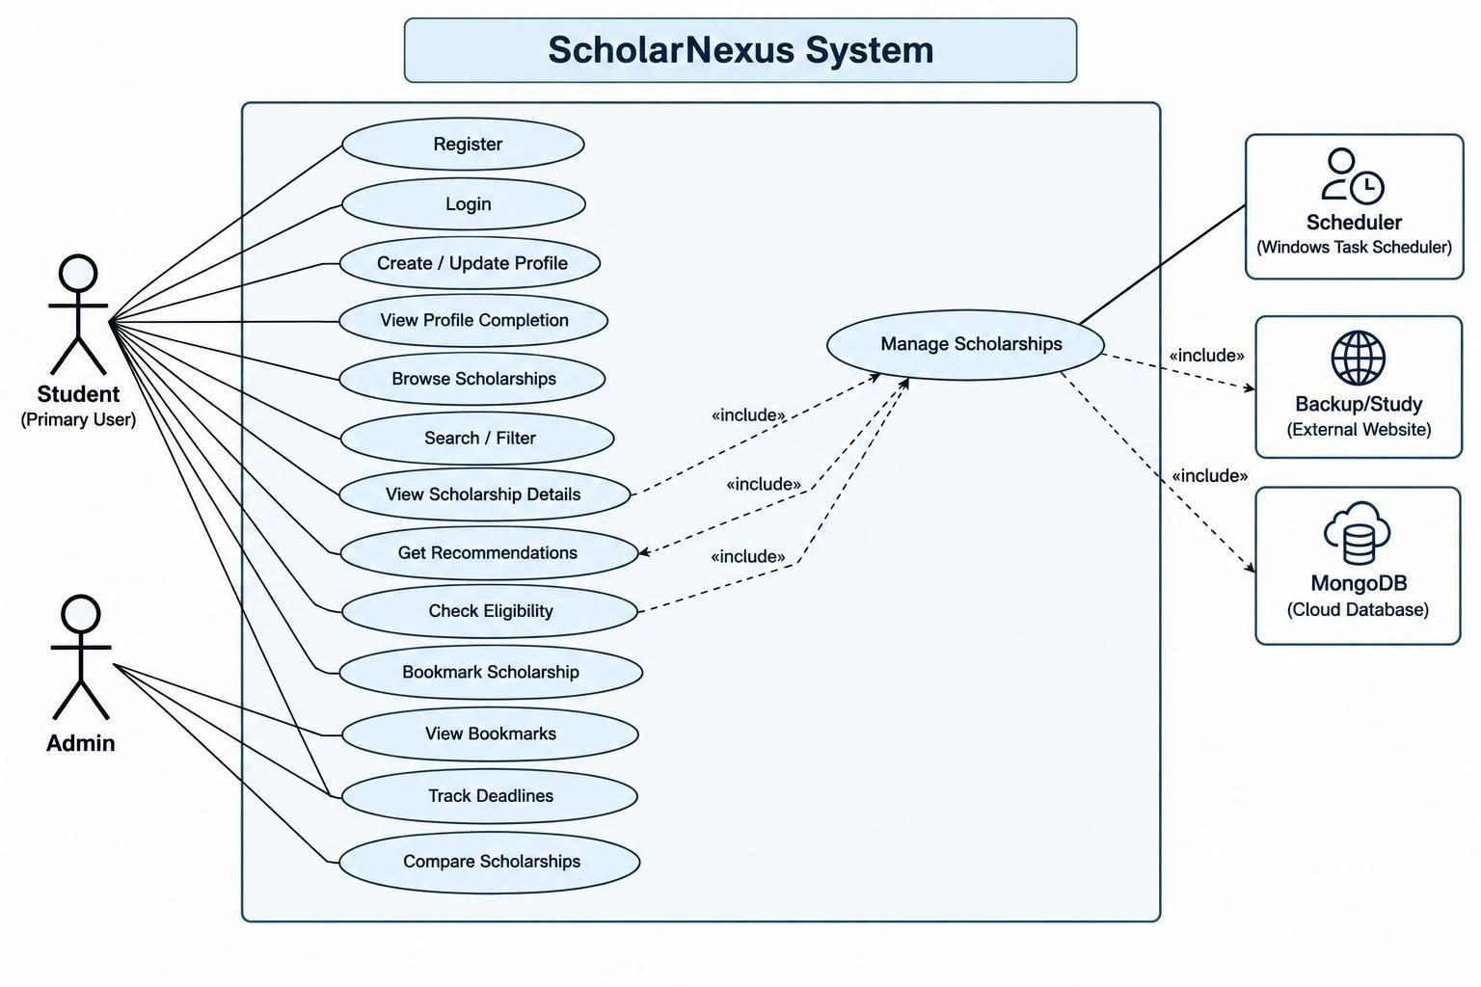
Figure 3.1 : use case diagram

2. DFD Level 0 (Context Diagram)

The Level 0 Data Flow Diagram (DFD) represents the Scholarship Navigator system as a single process and shows its interaction with external entities. It illustrates the flow of data between students, administrators, scholarship source we bsites, and the system

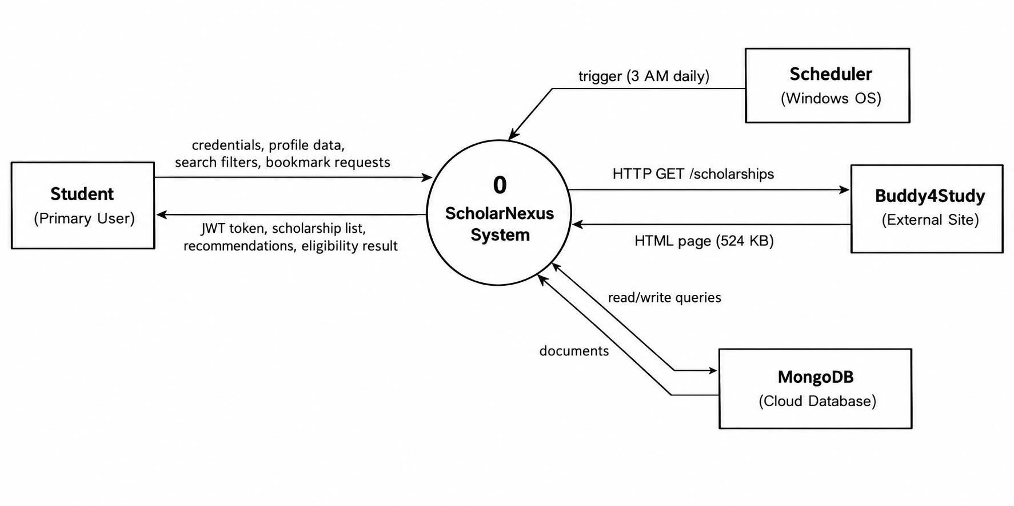

Figure 3.2 : DFD level 0

DFD Level 1
The Level 1 Data Flow Diagram provides a detailed representation of the major processes within the Scholarship Navigator system. It shows how scholarship data is collected, processed, stored, matched with student profiles, and presented as recommendations.

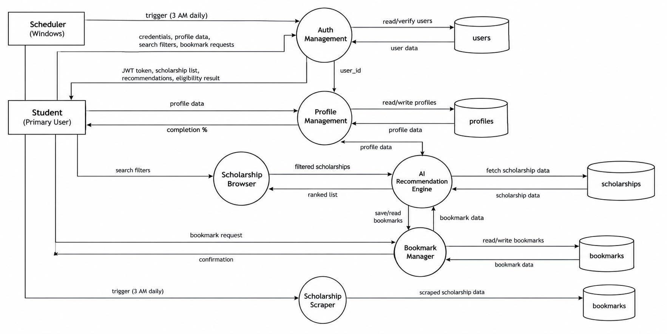

Figure 3.3 : DFD level 1

State Diagram
The State Diagram represents the different states of a scholarship record throughout its lifecycle, from discovery and data extraction to validation, publication, and archiving. It also illustrates the transitions between states based on system operations and administrative actions.
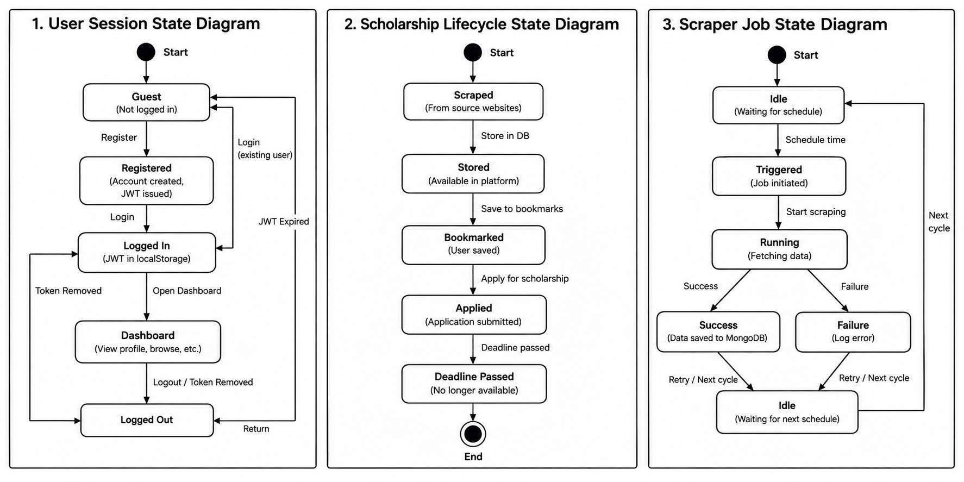

Figure 3.4: state diagram

Sequence Diagram
The Sequence Diagram illustrates the time-ordered interactions between the student, user interface, profile manager, matching engine, scholarship database, and recommendation ranker. It shows how these components communicate to generate and display suitable scholarship recommendations.

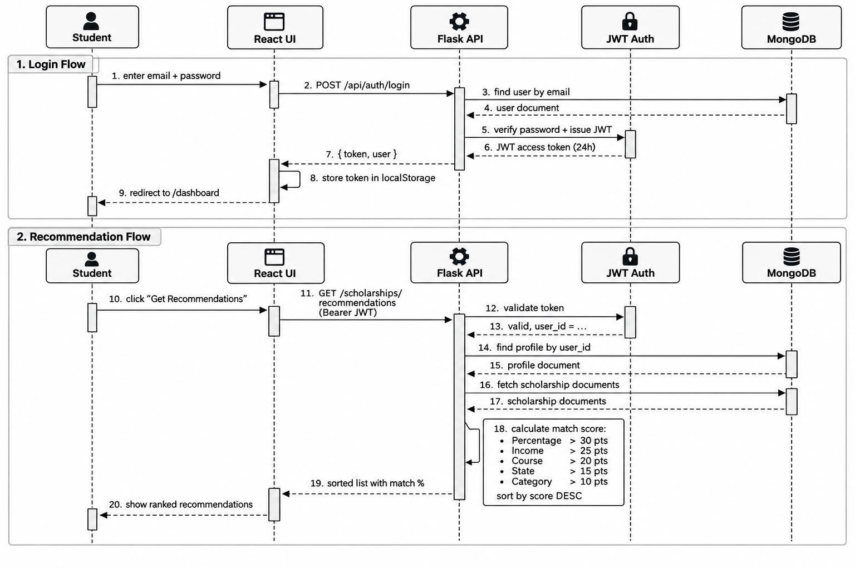
Figure 3.5: Sequence Diagram

Activity Diagram
The Activity Diagram represents the workflow of the Scholarship Navigator system, from collecting scholarship information and validating data to checking student eligibility and displaying recommendations. It also shows decision points that determine whether records are published, flagged for review, or filtered out.

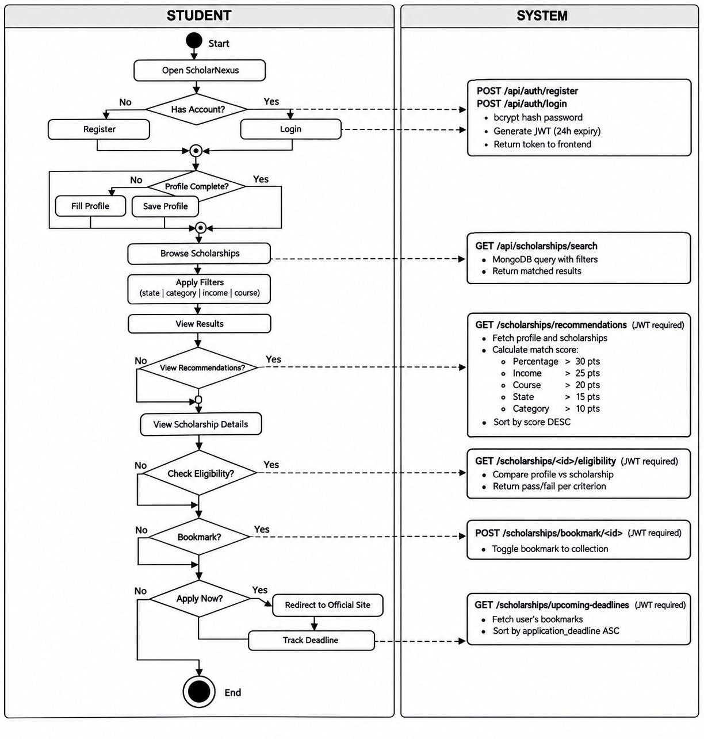
Figure 3.6: activity diagram

Database Design / ER Diagram
The Entity-Relationship (ER) Diagram represents the database structure of the Scholarship Navigator system, including entities such as Student, Scholarship, Source, Admin, and Match_Result. It illustrates the relationships between these entities and identifies their primary and foreign keys to support organized data storage and retrieval.

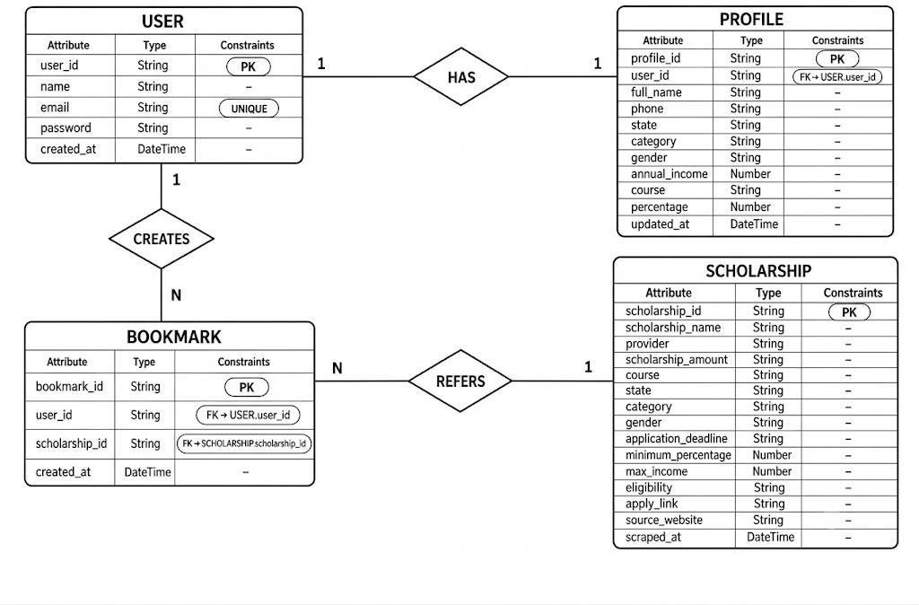
Figure 3.7 : database diagram

REFERENCES (TNR 16)(IEEE Format)
- Paper Name: Author(s), "Title of the Paper," Journal/Conference Name, Year, Pages.

- Book Name: Author(s), Book Title, Edition, Publisher, Year.

- Book Chapter: Author(s), "Chapter Title," in Book Title, Editor(s), Edition, Publisher, Year, Pages.

- Website: Author/Organization, "Title/Topic," Website Name, URL, Accessed on:
Date.

Example with proper numbering:

- J. Smith and R. Brown, "Machine Learning in Healthcare," International Journal of AI Research, 2022, pp. 45–60.

- A. Kumar, Discrete Mathematics and Its Applications, 8th ed., McGraw-Hill, 2019.

- M. Patel, "Graph Theory Basics," in Handbook of Discrete Mathematics, Ed. R.
Gupta, Springer, 2021, pp. 120–140.

- World Health Organization, "Artificial Intelligence in Health," WHO Official Website, https://www.who.int/news-room/artificial-intelligence, Accessed on: 06 Oct 2025.

ACKNOWLEDGEMENT

I/We would like to express my/our sincere gratitude to all those who have contributed to the successful completion of this project.
First and foremost, I/We extend heartfelt thanks to [Name of Guide/Supervisor], [Designation], Department of Computer Science and Engineering, Deogiri Institute of Engineering and Management Studies, Chhatrapati Sambhajinagar, for his/her valuable guidance, encouragement, and continuous support throughout the project. His/her insights and feedback greatly helped in the successful completion of this work.
I/We am/are also thankful to Dr. R. M. Autee, Head, Department of Computer Science and Engineering, for providing the necessary facilities and for his encouragement during the course of this project.
I/We would also like to express deep gratitude to Dr. Subhash V. Lahane, Director, Deogiri Institute of Engineering and Management Studies, Chhatrapati Sambhajinagar, for his constant support, visionary guidance, and encouragement in all academic endeavors.
Finally, I/We thank all faculty members, staff, friends, and family who directly or indirectly contributed to the successful completion of this project.

Signature(s) of Students
Name of Students | Sign
Name of Students | Sign
Name of Students | Sign
Name of Students | Sign

General Instructions
- Page Size – A4
- Margins – Left: 1.5”, Right: 0.5”, Top: 1”, Bottom: 1”
- No page border on any page like title, index, or chapter pages
- Chapter title should be TNR 16 Bold
- Chapter Text: 12 TNR
- Figure number and screen number should be Chapter Number. Figure Number e.g.
Figure 3.4, Screenshot 4.11
- Page numbering should start from List of Figures page in roman (iii, iv etc.) and chapter page numbering from 1 onwards
- Header “Chapter Title (right alignment)” footer “Page Number (center alignment)” should be included on all chapter pages.
- Submit a soft copy of this report in PDF Format to the concern Guide on mail.

